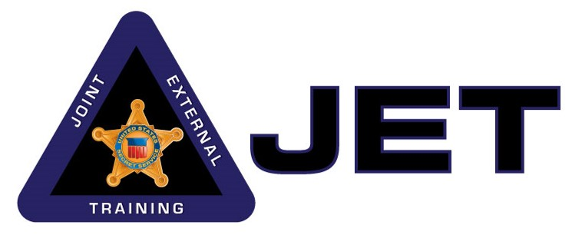

**Joint & External Training Section (JET)**

**USSS Rowley Training Center**

**Course Title: 1-Day Small Detail Protection Seminar**

**TARGET AUDIENCE:**

Federal, State and Local Sworn Law Enforcement officers and agents with experience in protection operations.

**COURSE DESCRIPTION:**

This course is designed to provide effective preventive and physical protection briefings and hands-on practice for our Federal, State and Local Sworn Law Enforcement partners currently assigned to small protective details. It is a condensed version of the JET 2-day Small Detail Protection Seminar. Lectures introduce officers and agents to the US Secret Service protection philosophy and protective methodologies with a focus on small detail operations. Lectures include: Site Advance, Shift Formations / Interior Tactics, Shift Deployments, and. Lectures are reinforced through hands-on practice guided by USSS instructors. This seminar devotes more time to repetition and practice and culminates in an exercise in which students use the lessons learned to complete a scenario-based protection visit. This course is not intended, nor should it be used to replace any department or agency’s current policies or procedures.

**LENGTH:** 08 hours

**ENROLLMENT PROCEDURE:**

A maximum of 8 participants is requested. Coordination through the JET section for dates / availability is required.

**2-DAY SEMINAR SCHEDULE:**

**DAY 1:**

Introduction and Safety Briefing                                       0800 - 0815

Site Advance Lecture                                                                          0815 - 0900

Site Advance Station                   0900 - 1000

Shift Formation Lecture        1000 – 1100

Lunch                                                                                                    1100 - 1200

Shift Formation Station 1200 - 1300

Shift Deployment Lecture 1300 - 1400

Shift Deployment Station 1400 - 1515

Table Top Exercise 1515 - 1545

Conclusion 1545 - 1600