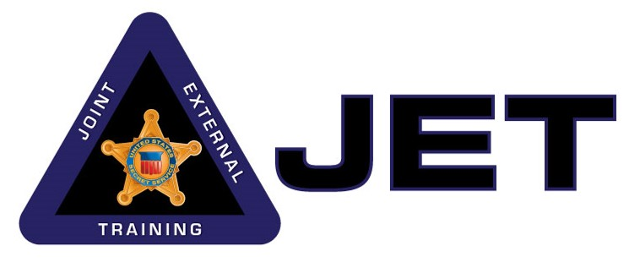

**Joint & External Training Section (JET)**

**USSS Rowley Training Center**

**Course Title: 2-Day Small Detail Protection Seminar**

**TARGET AUDIENCE:**

Federal, State and Local Sworn Law Enforcement officers and agents with experience in protection operations.

**COURSE DESCRIPTION:**

This course is designed to provide effective preventive and physical protection briefings and hands-on practice for our Federal, State and Local Sworn Law Enforcement partners currently assigned to small protective details. Lectures introduce officers and agents to the US Secret Service protection philosophy and protective methodologies with a focus on small detail operations. Lectures include: Site Advance, Shift Formations / Interior Tactics, Shift Deployments, and. Lectures are reinforced through hands-on practice guided by USSS instructors. This seminar devotes more time to repetition and practice and culminates in an exercise in which students use the lessons learned to complete a scenario-based protection visit. This course is not intended, nor should it be used to replace any department or agency’s current policies or procedures.

**LENGTH:** 16 hours

**ENROLLMENT PROCEDURE:**

A maximum of 8 participants is requested. Coordination through the JET section for dates / availability is required.

**2-DAY SEMINAR SCHEDULE:**

**DAY 1:**

Introduction and Safety Briefing                                       0800 - 0830

Site Advance Lecture                                                                          0830 - 0930

Site Advance Station                   0930 - 1100

Lunch                                                                                                    1100 - 1200

Shift Formation Lecture 1200 - 1330

Shift Formation Station 1330 - 1600

**DAY 2:**

Safety Briefing and Review 0800 - 0830

Shift Deployment Lecture 0830 - 0930

Shift Deployment Station 0930 - 1100

Lunch 1100 - 1200

Protection Exercise (Station Work) 1200 -1430

Table Top Exercise 1430 - 1530

Conclusion 1530 - 1600